Anthony Cunningham

STAT: 2010

11/6/2016

**Homework 10 SAS Code**

#1. **data** bliss ;

input group $ score ;

datalines;

A 29

A 28

.

.

P 12

;

**run** ;

**proc** **sort** data = bliss ; *sorts data by treatment received;

by group ;

**run** ;

**proc** **univariate** plot data = bliss ; *test for normality and outliers in each group

var score ;

by group ;

**run** ;

active-learning treatment group passive-learning treatment group

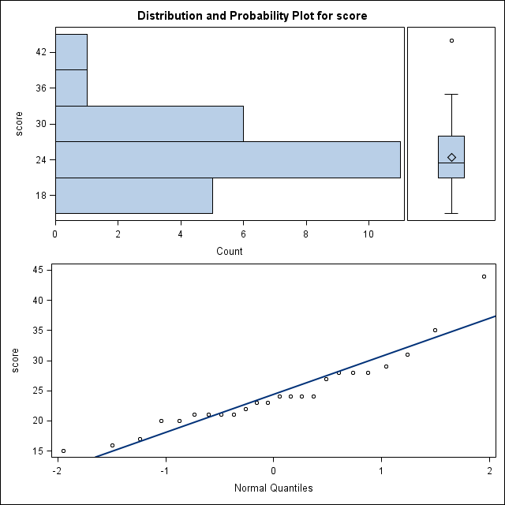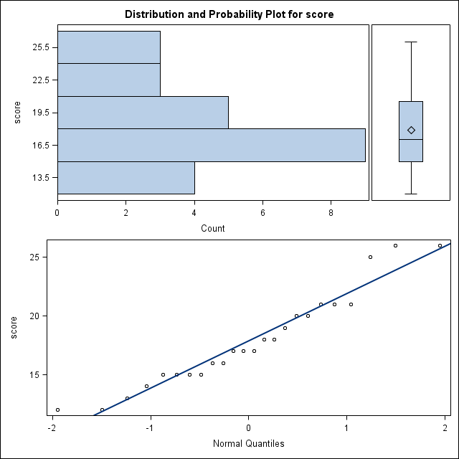

**proc** **ttest** alpha = **.10** data = bliss ; *obtain p-value and confidence intervals;

class group ;

var score ;

**run** ;

*p-value

Method Variances DF t Value Pr > |t|

Pooled Equal 46 4.28 <.0001

Satterthwaite Unequal 39.058 4.28 0.0001

*confidence intervals

group Method Mean 90% CL Mean Std Dev 90% CL Std Dev

A 24.4167 22.2091 26.6242 6.3102 5.1028 8.3643

P 17.8750 16.4669 19.2831 4.0251 3.2549 5.3353

Diff (1-2) Pooled 6.5417 3.9770 9.1063 5.2924 4.5285 6.4018

Diff (1-2) Satterthwaite 6.5417 3.9676 9.1157

#40.

**data** wine;

input winePreference count;

datalines;

1 22

2 10

;

**run**;

**proc** **freq** data=wine; *to find confidence interval;

tables winePreference / binomial (p = **0.6875**);

weight count;

**run**;

Binomial Proportion

winePreference = 1

Proportion 0.6875

ASE 0.0819

95% Lower Conf Limit 0.5269

95% Upper Conf Limit 0.8481

Exact Conf Limits

95% Lower Conf Limit 0.4999

95% Upper Conf Limit 0.8388

#42. **proc** **freq** data=wine; *to find p-value;

tables winePreference / binomial(p = **0.5**);

weight count;

**run**;

Test of H0: Proportion = 0.5

ASE under H0 0.0884

Z 2.1213

One-sided Pr > Z 0.0169

Two-sided Pr > |Z| 0.0339